**Power BI Assignment 3**

1. **List and explain different PowerBi products?**

**Answer: Power BI Desktop and Power BI Pro**

Power BI Desktop is the best choice for small teams who do not need large-scale collaboration and integration. It is bundled free with the Office 365 plan. Power BI Desktop is ideal if you are just starting out. Despite being free, it still offers various tools for organizing data, creating visualizations and reports using templates, and exporting and importing data from/to Excel and other tools.

Power BI Pro is an entry-level solution for enterprise users. It upgrades the Desktop product by offering team collaboration on shared dashboards and secure file sharing between Pro users.

Power BI Pro licenses are per-user, and any user you share reports with will need a Pro license to view them. This means it gets more expensive as the number of people who need to view your files (both inside and outside your organization) grows. In this situation, Power BI Premium can be a more cost-effective solution.

**Power BI Premium**

Power BI Premium is targeted at enterprises with heavy data processing needs. This is what you need if you want advanced AI features or have a large number of users that need to view reports and collaborate in real-time.

The plan is offered at both the user and enterprise levels. With a user license, users get all the benefits of Power BI Pro with advanced AI functionality, while the enterprise (per capacity) license allows you to share up to 10 GB of reporting and data with anyone, regardless of whether they are a Pro user or not. This allows for larger-scale collaboration and better performance if you size the capacity properly.

Simply put, a per-user Pro plan will suit small- and medium-sized businesses that create reports and visualizations but do not share information very often. A per-capacity Premium license is better for sharing information both inside and outside an organization.

**Power BI Mobile**

Power BI Mobile is a native mobile app for Android, iOS, and Windows Mobile that helps both managers and BI professionals keep tabs on important developments. BI professionals have the flexibility to connect to and interact with data whenever they need it, and managers can get the necessary insights from their devices at any time while on the move.

**Power BI Report Server**

Power BI Report Server is an on-premise version either delivered in one pack with Power BI Premium or built on top of the SQL Server Enterprise Edition framework. Power BI Report Server is ideal if you prefer to handle Power BI reports behind your organization’s firewalls. This version is cloud-ready, so migration will not be a headache if your company needs change.

**Power BI Embedded**

Power BI Embedded is a range of services that allows companies to use Power BI capabilities of displaying Power BI reports, dashboards, or visualizations with embedded analytics in their own apps. Its target audience is independent software vendors (ISVs) and developers who would like to add Power BI visuals into their products but under their own specific branding rules. You can also choose this Power BI product if you need to share your reports, dashboards or visuals, but without buying an MS Power BI Pro license for each consuming user.

1. **What limitations of Excel, Microsoft solved by PowerBi?**

**Answer:**

* **Excel** is used to **organize data, transform it and perform mathematical operations** and calculations. On the other hand, **Power BI** was conceived as a **business intelligence and data visualization tool for businesses**.
* **Excel** has **limitations** in the **amount of data** it can work with. In contrast, **Power BI** **can handle much larger amounts of data**.
* **Power BI can connect to a large number of data sources**, while Excel's connectivity capacity is limited. Also, unlike Excel, Power BI can be easily used from mobile devices.
* **Power BI** has **faster processing** than Excel.
* **Power BI dashboards** are [**more visually appealing, interactive and customizable**](https://blog.bismart.com/en/reporting-services-and-highly-visual-and-interactive-reports) than those in Excel.
* Power BI is a more powerful tool than Excel in terms of comparison between tables, reports or data files.
* **Power BI** is more user friendly and **easy to use** than Excel.

**3.Explain PowerQuery?**

**Answer:** Power Query is a data transformation and data preparation engine. Power Query comes with a graphical interface for getting data from sources and a Power Query Editor for applying transformations. Because the engine is available in many products and services, the destination where the data will be stored depends on where Power Query was used. Using Power Query, you can perform the extract, transform, and load (ETL) processing of data.

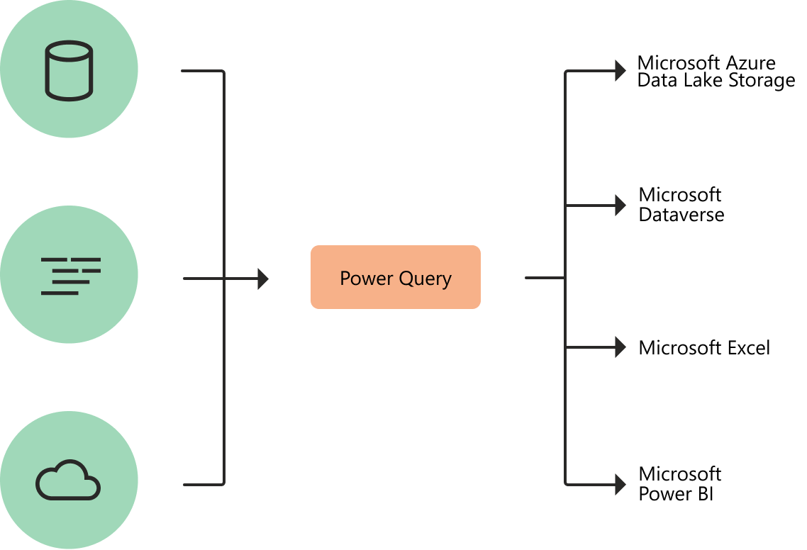

**4.Explain PowerMap?**

**Answer:** Microsoft Power Map for Excel is a three-dimensional (3-D) data visualization tool that lets you look at information in new ways. A power map lets you discover insights you might not see in traditional two-dimensional (2-D) tables and charts.



With Power Map, you can plot geographic and temporal data on a 3-D globe or custom map, show it over time, and create visual tours you can share with other people. You’ll want to use Power Map to:

* **Map data**    Plot more than a million rows of data visually on Bing maps in 3-D format from an Excel table or Data Model in Excel.
* **Discover insights**    Gain new understandings by viewing your data in geographic space and seeing time-stamped data change over time.
* **Share stories**    Capture screenshots and build cinematic, guided video tours you can share broadly, engaging audiences like never before. Or export tours to video and share them that way as well.

You’ll find the **Map** button in the **Tours** group on the **Insert** tab of the Excel ribbon, as shown in this picture.

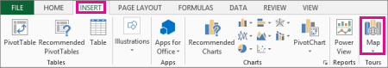

1. **How powerBi eliminated the need to host SharePoint Server on premises?**

### Answer: **InfoPath Forms Services**

InfoPath Forms Services is deprecated but will remain supported for the SharePoint Server Subscription Edition release until July 14, 2026. After that date, InfoPath Forms Services will no longer be supported. Microsoft recommends exploring Power Apps as a potential alternative to InfoPath forms.

**Microsoft Workflow Manager**

Microsoft has released SharePoint Workflow Manager as the new workflow engine to power the SharePoint 2013 Workflow platform for SharePoint Server and replace Microsoft Workflow Manager. We recommend that all customers using SharePoint 2013 workflows upgrade to SharePoint Workflow Manager as soon as they’re able to. Microsoft will focus all future investments and maintenance on SharePoint Workflow Manger rather than Microsoft Workflow Manager, including providing support beyond the year 2026.

**SharePoint 2010 workflows**

SharePoint 2010 workflows are deprecated but will remain supported for the SharePoint Server Subscription Edition release until July 14, 2026. After that date, SharePoint 2010 workflows will no longer be supported. Microsoft recommends exploring SharePoint 2013 workflows or Power Automate as potential alternatives to SharePoint 2010 workflows.

**SharePoint Designer 2013**

SharePoint Designer 2013 is deprecated but will remain supported with SharePoint Server Subscription Edition until July 14, 2026. After that date, SharePoint Designer 2013 will no longer be supported. Customers will be able to continue using Visual Studio to create and edit their SharePoint 2013 workflows after that date.

**Internet Explorer 11**

Internet Explorer 11 is only supported in the SharePoint Central Administration site. Internet Explorer 11 isn't supported in Team sites, OneDrive personal sites, or any other types of SharePoint content sites. Microsoft recommends exploring Microsoft Edge as the replacement for Internet Explorer 11.

**Basic authentication**

For many years, applications have used Basic authentication to connect to servers, services, and API endpoints. Basic authentication simply means the application sends a username and password with requests, making it easier for attackers to capture user credentials, which increases the risk of those stolen credentials being reused against other endpoints or services.

With these threats and risks in mind, Basic authentication is deprecated but will remain supported for the SharePoint Server Subscription Edition until July 14, 2026. After that date, Basic authentication will no longer be supported and will eventually be removed in SharePoint Server Subscription Edition for all scenarios. Microsoft recommends exploring Trusted Identity provider as the replacement for authentication.

**Access Services 2010**

Access Services 2010 was removed and is no longer supported by Microsoft in SharePoint Server Subscription Edition. We recommend exploring Microsoft Power Apps and Power Automate as potential alternatives to Access Services 2010.

**Access Services 2013**

Access Services 2013 was removed and is no longer supported by Microsoft in SharePoint Server Subscription Edition. We recommend exploring Microsoft Power Apps and Power Automate as potential alternatives to Access Services 2013.

**Classic authentication mode for content web applications**

Classic authentication mode was removed and is no longer supported by Microsoft for content web applications in SharePoint Server Subscription Edition. Content web applications will now only support claims authentication mode. The Central Administration web application continues to use and support classic authentication mode.

**Groove sync app support**

Groove sync app support was removed and is no longer supported by Microsoft in SharePoint Server Subscription Edition. We recommend exploring the Microsoft OneDrive sync app as the replacement for the Groove sync app.

**Lists web service APIs for Groove sync app**

The Lists web service APIs for Groove sync app were removed and are no longer supported by Microsoft in SharePoint Server Subscription Edition. We recommend exploring the Microsoft [OneDrive sync app](https://support.microsoft.com/office/sync-files-with-onedrive-in-windows-615391c4-2bd3-4aae-a42a-858262e42a49#bkmk_install) as the replacement for the Groove sync app.

**PerformancePoint Services**

PerformancePoint Services had a significant dependency on Microsoft Silverlight, which is a technology that is no longer be supported as of October 12, 2021. PerformancePoint Services was removed from SharePoint Server Subscription Edition. We recommend exploring Microsoft [Power BI](https://powerbi.microsoft.com/) as an alternative to PerformancePoint Services as we're making many new business intelligence investments in Power BI.

**Stsadm.exe command-line tool**

The stsadm.exe command-line administration tool was removed from SharePoint Server Subscription Edition. SharePoint PowerShell cmdlets can be used to administer SharePoint from the command line or through scripting.

**Update-SPHelp PowerShell cmdlet**

As SharePoint PowerShell cmdlets were converted from snap-ins to modules in SharePoint Server Subscription Edition, the Update-SPHelp cmdlet is no longer necessary to download the latest cmdlet help content. The Update-Help cmdlet will now be able to download the latest help content for SharePoint PowerShell cmdlets.

**Claims to Windows Token Service**

The Claims to Windows Token Service (C2WTS) was removed from SharePoint Server Subscription Edition. The service still appears in the Central Administration site, but the backing Windows service isn't installed, so the SharePoint service won't start. Trying to start the service in Central Administration results in error: **SPWindowsTokenServiceInstance: could not find c2wtshost.exe.config. Please edit the configuration manually.**  
SharePoint Server Subscription Edition replaced Windows Identity Foundation (WIF) 3.5 with WIF 4.5, in which the Claims to Windows Token Service and its associated classes are removed. If you have a custom solution that depends on the C2WTS, you may need to adjust it to work with WIF

1. **Explain the updates done in Power Bi Service(power BI 2.0) as compared to older version ?**

**Answer:** The following updates are new to Power BI Desktop the Month of May 2024.

### Reporting

* Modern Tooltip now on by default
* Matrix layouts
* Line updates
* On-object interactions updates
* Publish to folders (Preview)
* You can now ask Copilot questions about data in your model

### Modeling

* DAX Query View now generally available
* Copilot to write and explain DAX queries in DAX Query View updates (Preview)
* New Manage relationships dialog
* Refreshing calculated columns and calculated tables referencing DirectQuery sources with single sign-on
* Model explorer and authoring calculation groups in Power BI Desktop now generally available

### Data connectivity

* Microsoft Entra ID SSO support for Oracle database
* Certified connector updates
* View reports in OneDrive and SharePoint with live connected semantic models

### Visuals

* Many new and updated visuals

The following updates are new to the Power BI service:

* Storytelling in PowerPoint - Image mode in the Power BI add-in for PowerPoint
* Storytelling in PowerPoint - data updated notification